Operating Instructions Dosemate

Screen 1 : 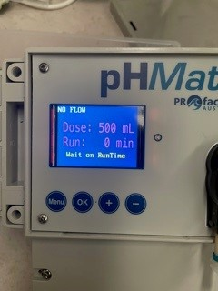
In this screen the Dosemate has the ability to work Without the Flow Switch Control. One can select the dosage required by pressing the + - Buttons. The unit will then dose the selected amount during the times selected in the Dose Run Time Menu (Screen 5)
Screen 2 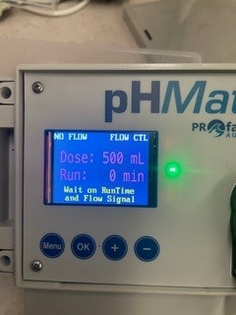
By pressing the OK button, the flow switch control is activated. One must ensure the flow switch is connected. When this option is selected the Dosemate will only function if there is flow in the line. The reason for this function is to ensure that Hazardous Chemicals are not being dosed while the filtration is not running.
Screen 3 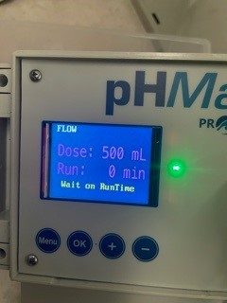
Shows the Flow Switch is activated and the filtration is running.

Screen 4: 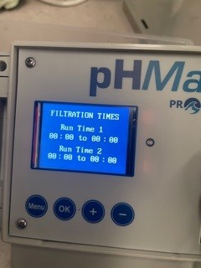
The Dosemate has an independent timer that allows 2 Runtime cycles.

Screen 5: 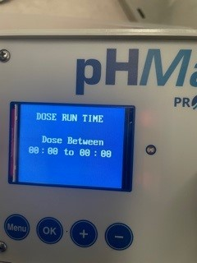
Ref Screen 1.

Screen 6: 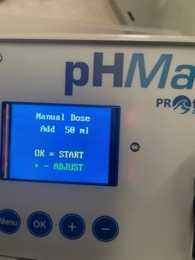
The Dosemate has the ability to do a manual feed outside the timer cycles. By pressing the + - buttons one can select the desired amount of manual feed required. Please always ensure the filtration is running while performing this function.

Screen 7: 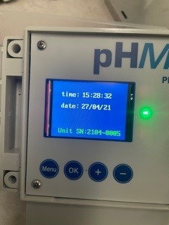
This screen has the Time, Date and Serial number of the unit. In this screen one would adjust the time of the day to match the region.

Please refer to the care and maintenance section of your Dosemate.

